How to change O-rings:
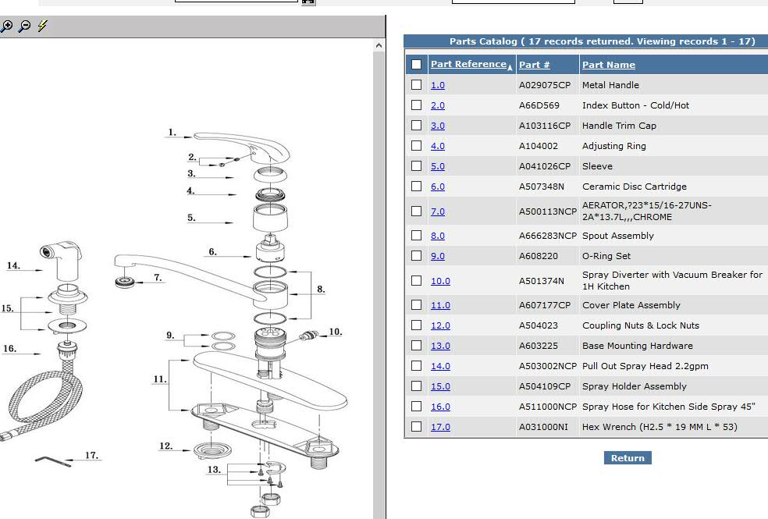
- Shut water off under the sink for hot and cold supply lines.
- Loosen the handle set screw part #2 (after pulling out the rubber index button), counter clockwise using hex wrench (1/8” or 2.5mm head).
- Pull up the handle part #1. If still difficult to be removed, loosen more the set screw.
- Unscrew the handle trim cap (part #3) counter clockwise by hand.
- Unscrew the brass adjusting ring (part # 4) counter clockwise by applying adjustable wrench on the two flat slots.
- Unscrew the sleeve (part #5) counter clockwise by hand and pull it up.
- Pull out cartridge part # 6. If it does not pull out easily, leave it to be pull out with the spout.
- Move spout part #8 left and right and up little by little until you remove it.
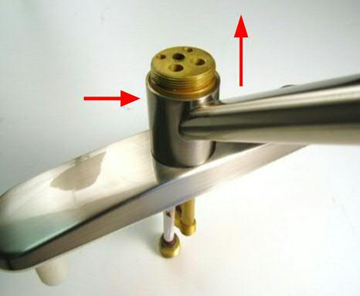
- Then you will find the faucet body exposed with 2 groves (each one has one O-ring) part # 9. Pull them out or cut them and install the new O-rings.
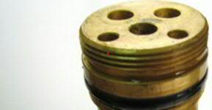
- Re-install all the parts back unto the unit (spout, sleeve, brass adjusting ring, handle trim cap, handle screw and index button).
